- \Operation\Downstream machine\Downstream machine
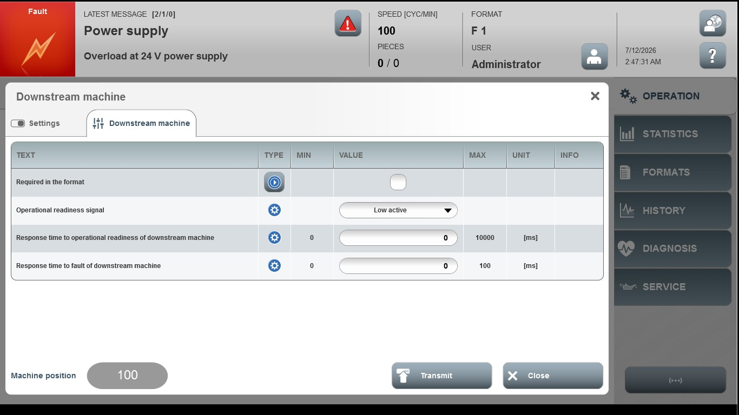

Acceptance criterion | Limits | Pass / Fail: Dev-No. | Date | Initials
Screen matches screenshot | N / A
Delay time for restart of cartoning machine | 0 … 10000
Response time to downstream machine fault | 0 … 5000

